
VELAMMAL VIDYALAYA SENIOR SECONDARY SCHOOL
KARUR
COMPUTER SCIENCE
PROJECT

Name : HARSHAN A M
Title : SUPERMARKET BILLING SOFTWARE
Exam No. : _________________________

Under the Guidance of
Mr. Kishor Kumaar S

2022-23


VELAMMAL VIDYALAYA
SENIOR SECONDARY SCHOOL
KARUR
COMPUTER SCIENCE PROJECT

CERTIFICATE

This is to certify that this is the bonafide record of project work done by Master HARSHAN A M of Grade XII during the academic year 2022-23.
Submitted for AISSCE COMPUTER SCIENCE Practical Examination held on ____ / ___ / _______ at Velammal Vidyalaya Senior Secondary School, Karur.
Date: ______________

Guide Internal Examiner

Principal External Examiner

ACKNOWLEDGEMENT
Apart from the efforts of me, the success of any project depends largely on the encouragement and guidelines of many others. I take this opportunity to express my gratitude to the people who have been instrumental in the successful completion of this project.
I express deep sense of gratitude to almighty God for giving me strength for the successful completion of the project.
I express my heartfelt gratitude to my parents for constant encouragement while carrying out this project.
I gratefully acknowledge the contribution of the individuals who contributed in bringing this project up to this level, who continues to look after me despite my flaws,
I express my deep sense of gratitude to the luminary The Chairman, Velammal Vidyalaya who has been continuously motivating and extending their helping hand to us.
I express my sincere thanks to the academician The Principal, Velammal Vidyalaya for constant encouragement and the guidance provided during this project
I am overwhelmed to express my thanks to The Administrative Officer and all staff members for providing me an infrastructure and moral support while carrying out this project in the school.
My sincere thanks to Mr. Kishor Kumaar S, Master In-charge, A guide, Mentor all the above a friend, who critically reviewed my project and helped in solving each and every problem, occurred during implementation of the project.
The guidance and support received from all the members who contributed and who are contributing to this project, was vital for the success of the project. I am grateful for their constant support and help.
Reg. No.:

CONTENT

S.NO. | PARTICULARS | PAGE NO.
1 | INTRODUCTION
2 | OBJECTIVE
3 | HARDWARE AND SOFTWARE DESCRIPTION
4 | PROPOSED SYSTEM
5 | FLOW CHART
6 | CODING
7 | OUTPUT
8 | CONCLUSION
9 | BIBLIOGRAPHY
10 | WEBLIOGRAPHY

PROJECT ON SUPERMARKET BILLING SOFTWARE

INTRODUCTION

This software is used to maintain the shop customer detail, product details, maintain the shop in updated and maintain records of in and out data of shop
OBJECTIVES OF THE PROJECT
The objective of this project is to let the students apply the programming knowledge into a real- world situation/problem and exposed the students how programming skills helps in developing a good software.
- Write programs utilizing modern software tools.
- Apply object oriented programming principles effectively when developing small to medium sized projects.
- Write effective procedural code to solve small to medium sized problems.
- Students will demonstrate a breadth of knowledge in computer science, as exemplified in the areas of systems, theory and software development.
- Students will demonstrate ability to conduct a research or applied Computer Science project, requiring writing and presentation skills which exemplify scholarly style in computer science.

HARDWARE AND SOFTWARE REQUIREMENTS

I.OPERATING SYSTEM : WINDOWS 10 AND ABOVE
II. PROCESSOR : PENTIUM(ANY) OR AMD
ATHALON(3800+- 4200+ DUAL CORE)
III. MOTHERBOARD : 1.845 OR 915,995 FOR PENTIUM 0R MSI
K9MM-V VIA K8M800+8237R PLUS CHIPSET FOR AMD ATHALON
IV. RAM : 512MB+
V. Hard disk : SATA 40 GB OR ABOVE
VI. CD/DVD r/w multi drive combo: (If back up required)
VII. FLOPPY DRIVE 1.44 MB : (If Backup required)
VIII. MONITOR 14.1 or 15 -17 inch
IX. Key board and mouse
X. Printer : (if print is required – [Hard copy])

SOFTWARE REQUIREMENTS:

- Windows OS
- Python
- mysql

PROPOSED SYSTEM

Today one cannot afford to rely on the fallible human beings of be really wants to stand against today’s merciless competition where not to wise saying “to err is human” no longer valid, it’s outdated to rationalize your mistake. So, to keep pace with time, to bring about the best result without malfunctioning and greater efficiency so to replace the unending heaps of flies with a much sophisticated hard disk of the computer.

One has to use the data management software. Software has been an ascent in atomization various organizations. Many software products working are now in markets, which have helped in making the organizations work easier and efficiently. Data management initially had to maintain a lot of ledgers and a lot of paper work has to be done but now software product on this organization has made their work faster and easier. Now only this software has to be loaded on the computer and work can be done.

This prevents a lot of time and money. The work becomes fully automated and any information regarding the organization can be obtained by clicking the button. Moreover, now it’s an age of computers of and automating such an organization gives the better look.

SYSTEM DEVELOPMENT LIFE CYCLE (SDLC)

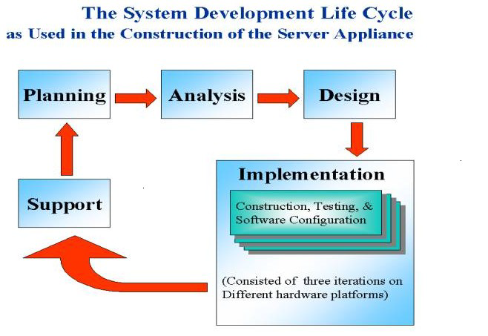

The systems development life cycle is a project management technique that divides complex projects into smaller, more easily managed segments or phases. Segmenting projects allows managers to verify the successful completion of project phases before allocating resources to subsequent phases.
Software development projects typically include initiation, planning, design, development, testing, implementation, and maintenance phases. However, the phases may be divided differently depending on the organization involved.
For example, initial project activities might be designated as request, requirements-definition, and planning phases, or initiation, concept-development, and planning phases. End users of the system under development should be involved in reviewing the output of each phase to ensure the system is being built to deliver the needed functionality.

PHASES OF SYSTEM DEVELOPMENT LIFE CYCLE

INITIATION PHASE

The Initiation Phase begins when a business sponsor identifies a need or an opportunity.

The purpose of the Initiation Phase is to:

- Identify and validate an opportunity to improve business accomplishments of the organization or a deficiency related to a business need.
- Identify significant assumptions and constraints on solutions to that need.
- Recommend the exploration of alternative concepts and methods to satisfy the need including questioning the need for technology, i.e., will a change in the business process offer a solution?
- Assure executive business and executive technical sponsorship. The Sponsor designates a Project Manager and the business need is documented in a Concept Proposal. The Concept Proposal includes information about the business process and the relationship to the Agency/Organization.
- Infrastructure and the Strategic Plan. A successful Concept Proposal results in a Project Management Charter which outlines the authority of the project manager to begin the project.

Careful oversight is required to ensure projects support strategic business objectives and resources are effectively implemented into an organization's enterprise architecture. The initiation phase begins when an opportunity to add, improve, or correct a system is identified and formally requested through the presentation of a business case. The business case should, at a minimum, describe a proposal’s purpose, identify expected benefits, and explain how the proposed system supports one of the organization’s business strategies. The business case should also identify alternative solutions and detail as many informational, functional, and network requirements as possible.

SYSTEM CONCEPT DEVELOPMENT PHASE

The System Concept Development Phase begins after a business need or opportunity is validated by the Agency/Organization Program Leadership and the Agency/Organization CIO.

The purpose of the System Concept Development Phase is to:

- Determine the feasibility and appropriateness of the alternatives.
- Identify system interfaces.
- Identify basic functional and data requirements to satisfy the business need.
- Establish system boundaries; identify goals, objectives, critical success factors, and performance measures.
- Evaluate costs and benefits of alternative approaches to satisfy the basic functional requirements
- Assess project risks
- Identify and initiate risk mitigation actions, and Develop high-level technical architecture, process models, data models, and a concept of operations. This phase explores potential technical solutions within the context of the business need.
- It may include several trade-off decisions such as the decision to use COTS software products as opposed to developing custom software or reusing software components, or the decision to use an incremental delivery versus a complete, onetime deployment.
- Construction of executable prototypes is encouraged to evaluate technology to support the business process. The System Boundary Document serves as an important reference document to support the Information Technology Project Request (ITPR) process.
- The ITPR must be approved by the State CIO before the project can move forward.

PICTORIAL REPRESENTATION OF SDLC:

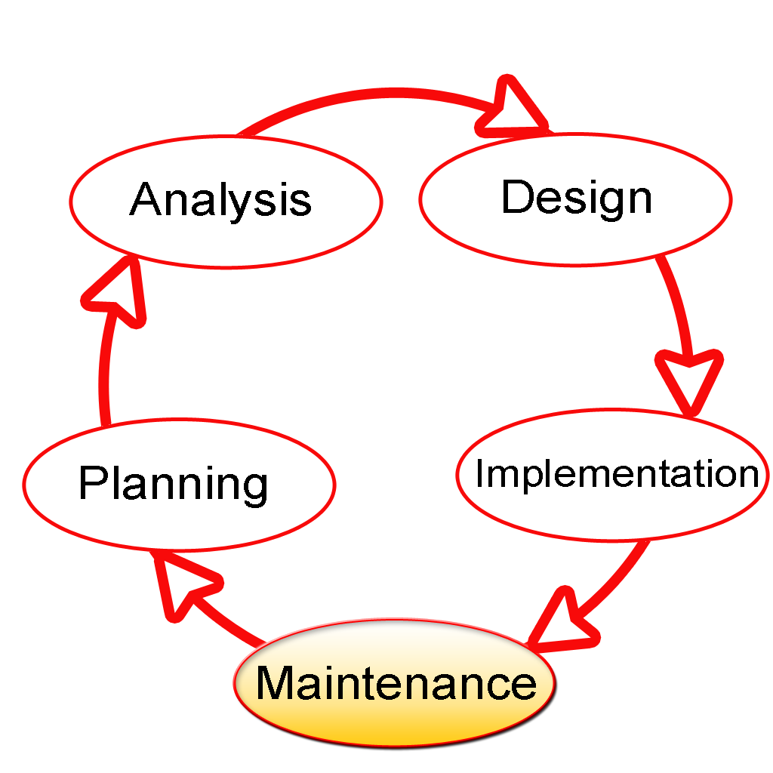

PLANNING PHASE

The planning phase is the most critical step in completing development, acquisition, and maintenance projects. Careful planning, particularly in the early stages of a project, is necessary to coordinate activities and manage project risks effectively. The depth and formality of project plans should be commensurate with the characteristics and risks of a given project. Project plans refine the information gathered during the initiation phase by further identifying the specific activities and resources required to complete a project.
A critical part of a project manager’ sjob is to coordinate discussions between user, audit, security, design, development, and network personnel to identify and document as many functional, security, and network requirements as possible. During this phase, a plan is developed that documents the approach to be used and includes a discussion of methods, tools, tasks, resources, project schedules, and user input. Personnel assignments, costs, project schedule, and target dates are established.
A Project Management Plan is created with components related to acquisition planning, configuration management planning, quality assurance planning, concept of operations, system security, verification and validation, and systems engineering management planning.

REQUIREMENTS ANALYSIS PHASE

This phase formally defines the detailed functional user requirements using high-level requirements identified in the Initiation, System Concept, and Planning phases. It also delineates the requirements in terms of data, system performance, security, and maintainability requirements for the system. The requirements are defined in this phase to a level of detail sufficient for systems design to proceed. They need to be measurable, testable, and relate to the business need or opportunity identified in the Initiation Phase. The requirements that will be used to determine acceptance of the system are captured in the Test and Evaluation Master Plan.
The purposes of this phase are to:

- Further define and refine the functional and data requirements and document them in the Requirements Document,
- Complete business process reengineering of the functions to be supported (i.e., verify what information drives the business process, what information is generated, who generates it, where does the information go, and who processes it),
- Develop detailed data and process models (system inputs, outputs, and the process.
- Develop the test and evaluation requirements that will be used to determine acceptable system performance.

DESIGN PHASE

The design phase involves converting the informational, functional, and network requirements identified during the initiation and planning phases into unified design specifications that developers use to script programs during the development phase. Program designs are constructed in various ways. Using a top-down approach, designers first identify and link major program components and interfaces, then expand design layouts as they identify and link smaller subsystems and connections. Using a bottom-up approach, designers first identify and link minor program components and interfaces, then expand design layouts as they identify and link larger systems and connections. Contemporary design techniques often use prototyping tools that build mock-up designs of items such as application screens, database layouts, and system architectures. End users, designers, developers, database managers, and network administrators should review and refine the prototyped designs in an iterative process until they agree on an acceptable design. Audit, security, and quality assurance personnel should be involved in the review and approval process. During this phase, the system is designed to satisfy the functional requirements identified in the previous phase. Since problems in the design phase could be very expensive to solve in the later stage of the software development, a variety of elements are considered in the design to mitigate risk. These include:
- Identifying potential risks and defining mitigating design features.
- Performing a security risk assessment.
- Developing a conversion plan to migrate current data to the new system.
- Determining the operating environment.
- Defining major subsystems and their inputs and outputs.
- Allocating processes to resources.
- Preparing detailed logic specifications for each software module. The result is a draft System Design Document which captures the preliminary design for the system.
- Everything requiring user input or approval is documented and reviewed by the user. Once these documents have been approved by the Agency CIO and Business Sponsor, the final System Design Document is created to serve as the Critical/Detailed Design for the system.
- This document receives a rigorous review by Agency technical and functional representatives to ensure that it satisfies the business requirements. Concurrent with the development of the system design, the Agency Project Manager begins development of the Implementation Plan, Operations and Maintenance Manual, and the Training Plan.

DEVELOPMENT PHASE

The development phase involves converting design specifications into executable programs. Effective development standards include requirements that programmers and other project participants discuss design specifications before programming begins. The procedures help ensure programmers clearly understand program designs and functional requirements. Programmers use various techniques to develop computer programs. The large transaction oriented programs associated with financial institutions have traditionally been developed using procedural programming techniques. Procedural programming involves the line-by-line scripting of logical instructions that are combined to form a program. Effective completion of the previous stages is a key factor in the success of the Development phase. The Development phase consists of:

- Translating the detailed requirements and design into system components.
- Testing individual elements (units) for usability.
- Preparing for integration and testing of the IT system.

INTEGRATION AND TEST PHASE

- Subsystem integration, system, security, and user acceptance testing is conducted during the integration and test phase. The user, with those responsible for quality assurance, validates that the functional requirements, as defined in the functional requirements document, are satisfied by the developed or modified system. OIT Security staff assess the system security and issue a security certification and accreditation prior to installation/implementation.

Multiple levels of testing are performed, including:

- Testing at the development facility by the contractor and possibly supported by end users

- Testing as a deployed system with end users working together with contract personnel

- Operational testing by the end user alone performing all functions. Requirements are traced throughout testing, a final Independent Verification & Validation evaluation is performed and all documentation is reviewed and accepted prior to acceptance of the system.

IMPLEMENTATION PHASE

This phase is initiated after the system has been tested and accepted by the user. In this phase, the system is installed to support the intended business functions. System performance is compared to performance objectives established during the planning phase. Implementation includes user notification, user training, installation of hardware, installation of software onto production computers, and integration of the system into daily work processes. This phase continues until the system is operating in production in accordance with the defined user requirements.

OPERATIONS AND MAINTENANCE PHASE

The system operation is ongoing. The system is monitored for continued performance in accordance with user requirements and needed system modifications are incorporated. Operations continue as long as the system can be effectively adapted to respond to the organization’s needs. When modifications or changes are identified, the system may reenter the planning phase.

The purpose of this phase is to:

- Operate, maintain, and enhance the system.
- Certify that the system can process sensitive information.
- Conduct periodic assessments of the system to ensure the functional requirements continue to be satisfied.
- Determine when the system needs to be modernized, replaced, or retired.

FLOW CHART

python-Mysql connecting

software login with username &password

ask user to enter his choice

your need will be fulfilled by python by interfacing with mysql

SOURCE CODE

from tkinter import *
from tkinter import ttk
from tkinter.font import Font
from PIL import Image,ImageTk
import mysql.connector as sql
from tkinter import messagebox
from datetime import date
from time import strftime

db=sql.connect(host='localhost',user='root',passwd='1234')
cursor=db.cursor()

cursor.execute('CREATE DATABASE IF NOT EXISTS BILLING_SOFTWARE')
cursor.execute('use billing_software')
cursor.execute('create table if not exists mg(mg_id int,name varchar(20),password varchar(20),dob char(10))')
cursor.execute('create table if not exists product_details(item_id int primary key auto_increment,item_name varchar(20),price float)')
cursor.execute('create table if not exists customer_details(cust_id int primary key auto_increment,cust_name varchar(20),cust_phone bigint)')
cursor.execute('create table if not exists bill(bill_id int,cust_id int,item_id int,qty int,bill_date date,amount float)')

q=0
def phcheck(ph):
t=True
while t:
if ph.isdigit():
x=str(ph)
l=['6','7','8','9']
if len(x)==10 and x[0] in l:
t=False
global q
q=1

else:
#messagebox.showerror('Phone Number','Phone Number is Invalid')
t=False
else:
#messagebox.showerror('Phone Number','Phone Number is Invalid')
t=False

def bill_win():
mgr.destroy()
def newcuswin():
def newcussub():
if nlen.get()=='' or plen.get()=='':
messagebox.showwarning('FIELD','EMPTY FIELDS ARE NOT ALLOWED')
elif nlen.get().isalpha() and plen.get().isdigit():
phcheck(plen.get())
if q==1:
cursor.execute('insert into customer_details (cust_name,cust_phone) values (%s,%s)',(nlen.get(),plen.get()))
db.commit()
newcus.destroy()
else:
messagebox.showerror('PH_NO','INVALID PHONE NUMBER')
else:
messagebox.showerror('INVALID','INVALID DATA')

newcus=Tk()
newcus.geometry('600x400')
newcus.resizable(0,0)
newcus.title('NEW CUSTOMER')
o=Label(newcus,text='CUSTOMER DETAILS',font=('stencil',25,'bold'),fg='red',pady=30,bg='#76b5c5')
o.pack(fill=X)
nl=Label(newcus,text='CUSTOMER NAME :',font=('arial',15),padx=10,pady=8)
nl.place(x=50,y=160)
pl=Label(newcus,text='PHONE NUMBER :',font=('arial',15),padx=10,pady=8)
pl.place(x=65,y=220)
nlen=Entry(newcus,width=15,font=('arial',14,'bold'))
nlen.place(x=280,y=168)
plen=Entry(newcus,width=15,font=('arial',14,'bold'))
plen.place(x=280,y=228)
subbtn=Button(newcus,text='SUBMIT',bg='green',fg='white',activeforeground='black',activebackground='white',padx=20,pady=5,command=newcussub)
subbtn.place(x=240,y=290)
billwin=Tk()
billwin.title('BILLING')
billwin.state('zoomed')
l=Label(billwin,text='XYZ SUPERMARKET',font=('stencil',25,'bold'),fg='red',pady=50,bg='#76b5c5')
l.pack(fill=X)
pidl=Label(billwin,text='P_ID :',font=('arial',15),padx=10,pady=8)
pidl.place(x=230,y=250)
qtyl=Label(billwin,text='QTY :',font=('arial',15),padx=10,pady=8)
qtyl.place(x=231,y=320)
global netamount
netamount=0
def updttrv():
global netamount
cursor.execute('select * from product_details')
vl=cursor.fetchall()
if pidbill.get()=='' or qtybill.get()=='':
messagebox.showerror('FIELD','EMPTY FIELDS ARE NOT ALLOWED')
elif pidbill.get().isalpha() or qtybill.get().isalpha():
messagebox.showerror('INVALID','INVALID DATA')
elif (qtybill.get())==str(0):
messagebox.showerror('INVALID','QTY CANT"T BE ZERO')
else:
cursor.execute('select * from product_Details where item_id=%s',(pidbill.get(),))
vl=cursor.fetchall()
if vl==[]:
messagebox.showerror('INVALID','P_ID NOT FOUND IN THE DATABASE')
else:
iname,mrp=vl[0][1],vl[0][2]
amount=mrp*int(qtybill.get())
netamount+=amount
rowv=(pidbill.get(),iname,mrp,qtybill.get(),amount)
billtrv.insert('',END,values=rowv)
ntamt()

def ntamt():
ntam.config(text=netamount)

def get_valuebill(event):
curs=billtrv.focus()
item=billtrv.item(curs)
row=item['values']
pidt.set(row[0])

def get_valuepro(event):
curs=probilltrv.focus()
item=probilltrv.item(curs)
row=item['values']
pidt.set(row[0])
pidt=IntVar()
pidbill=Entry(billwin,width=10,font=('arial',14,'bold'),textvariable=pidt)
pidbill.place(x=350,y=259)
pidbill.delete(0,END)
qtybill=Entry(billwin,width=10,font=('arial',14,'bold'))
qtybill.place(x=350,y=329)
global searchicon

searchicon=Image.open('E:/CS PROJECT/BILLING SOFTWARE TK/searchicon.png')
searchicon=searchicon.resize((22,22))
searchicon=ImageTk.PhotoImage(searchicon)
searchiconbtn=Button(billwin,image=searchicon,bd=3,relief='groove')
searchiconbtn.place(x=500,y=260)
#product treeview
global probilltrv
th=ttk.Style()
th.theme_use('clam')
th.configure('Treeview.Heading',background='green3')
cols=('P_ID','P_NAME','PRICE')
probilltrv=ttk.Treeview(billwin,columns=cols,show='headings')
probilltrv.heading('P_ID',text='P_ID')
probilltrv.heading('P_NAME',text='P_NAME')
probilltrv.heading('PRICE',text='PRICE')
probilltrv.column('P_ID',width=80)
probilltrv.column('PRICE',width=80)
probilltrv.place(x=800,y=200)
probilltrv.bind('<Double-Button-1>',get_valuepro)
cursor.execute('select * from product_Details')
dt=cursor.fetchall()
for i in dt:
probilltrv.insert('',END,values=i)
probillbar=ttk.Scrollbar(billwin,orient=VERTICAL,command=probilltrv.yview)
probilltrv.configure(yscrollcommand=probillbar.set)
probillbar.place(x=1164,y=200,height=229)

qtyaddbtn=Button(billwin,text='ADD',bg='green',fg='white',activeforeground='black',activebackground='white',padx=5,pady=3,command=updttrv)
qtyaddbtn.place(x=496,y=329)

th=ttk.Style()
th.theme_use('clam')
th.configure('Treeview.Heading',background='green3')
cols=('P_ID','P_NAME','MRP','QTY','AMOUNT')
global billtrv
billtrv=ttk.Treeview(billwin,columns=cols,show='headings')
billtrv.heading('P_ID',text='P_ID')
billtrv.heading('P_NAME',text='P_NAME')
billtrv.heading('MRP',text='MRP')
billtrv.heading('QTY',text='QTY')
billtrv.heading('AMOUNT',text='AMOUNT')
billtrv.column('P_ID',width=80)
billtrv.column('QTY',width=80)
billtrv.column('MRP',width=80)
#billtrv.bind('<Double-Button-1>',get_valuebill)
billtrv.place(x=140,y=450)
billbar=ttk.Scrollbar(billwin,orient=VERTICAL,command=billtrv.yview)
billtrv.configure(yscrollcommand=billbar.set)
billbar.place(x=785,y=450,height=229)

ntamtl=Label(billwin,text='NET AMOUNT =',font=('arial',15),padx=10,pady=8)
ntamtl.place(x=880,y=520)

ntam=Label(billwin,text='0',fg='red',font=('stencil',25,'bold'),padx=10)
ntam.place(x=1090,y=520)

def billtrvcheck():
blst=[]
for child in billtrv.get_children():
blst=billtrv.item(child)['values']
if blst==[]:
messagebox.showerror('','error')
else:
genbill()

def billsql():

def last_bill_no():
cursor.execute('select max(bill_id) from bill')
record = cursor.fetchone()
return record
bill_no = last_bill_no()
if bill_no[0]==None:
bill_no =1
else:
bill_no = bill_no[0]+1
today = date.today()
if cen.get()=='':
messagebox.showwarning('FIELD','EMPTY FIELDS ARE NOT ALLOWED')
elif cen.get().isdigit():
cursor.execute('select * from customer_details where cust_phone=%s',(int(cen.get()),))
j=cursor.fetchall()
if j==[]:
messagebox.showerror('NOT FOUND','ID NOT FOUND IN THE DATABASE')
else:
ci=j[0][0]
for child in billtrv.get_children():
billlist=billtrv.item(child)['values']

sql=('insert into bill values (%s,%s,%s,%s,%s,%s)')
val=(bill_no,ci,billlist[0],billlist[3],today,billlist[4])
cursor.execute(sql,val)
db.commit()
gb.destroy()
for i in billtrv.get_children():
billtrv.delete(i)
pidbill.delete(0,END)
qtybill.delete(0,END)
ntam.config(text='0')

else:
messagebox.showerror('INVALID','INVALID DATA')

def genbill():

def custinput():
if cen.get()=='':
messagebox.showwarning('INVALID','EMPTY FIELDS ARE NOT ALLOWED')
elif cen.get().isdigit():

cidg=int(cen.get())
cursor.execute('select * from customer_details where cust_phone=%s',(cidg,))
det=cursor.fetchall()
if det==[]:
messagebox.showinfo('INFO','CUST_PH.NO NOT FOUND IN THE DATABASE')
else:
cn=det[0][1]
cntext.set(cn)

else:
messagebox.showerror("INVALID",'INVALID PHONE NUMBER')

global cen
global gb
gb=Toplevel()
gb.geometry('600x600')
gb.resizable(0,0)
gb.title('GENERATE BILL')
cid=Label(gb,text='CUSTOMER_PH.NO :',font=('arial',15),padx=10,pady=8)
cid.place(x=30,y=100)
cntext=StringVar()
cphtext=StringVar()
cen=Entry(gb,width=15,font=('arial',14,'bold'))
cen.place(x=280,y=107)
global cuss
cuss=Image.open('E:\\CS PROJECT\\BILLING SOFTWARE TK\\searchicon.png')
cuss=cuss.resize((21,21))
cuss=ImageTk.PhotoImage(cuss)
sbtn=Button(gb,image=cuss,bd=5,relief='groove',command=custinput)
sbtn.place(x=458,y=106)
cnamel=Label(gb,text='CUSTOMER_NAME :',font=('arial',15),padx=10,pady=8)
cnamel.place(x=32,y=180)
cnameen=Entry(gb,width=12,font=('arial',14,'bold'),state='readonly',textvariable=cntext)
cnameen.place(x=280,y=190)
sqlbtn=Button(gb,text='SUBMIT',bg='green',fg='white',activeforeground='black',activebackground='white',padx=20,pady=5,command=billsql)
sqlbtn.place(x=250,y=350)
newcusbtn=Button(gb,text='NEW CUSTOMER',fg='red',font=(10),command=newcuswin)
newcusbtn.place(x=230,y=430)

genbillbtn=Button(billwin,text='GENERATE BILL',bg='green',fg='white',activeforeground='black',activebackground='white',font=(8),padx=10,pady=3,command=billtrvcheck)
genbillbtn.place(x=980,y=600)

def billback_():
billwin.destroy()
mgrwin()

global billbackimg
billback=Image.open('E:\\CS PROJECT\\BILLING SOFTWARE TK\\backarrowicon.png')
billback=billback.resize((35,30))
billbackimg=ImageTk.PhotoImage(billback)
billbackbtn=Button(billwin,image=billbackimg,borderwidth=0,cursor='hand2',command=billback_)
billbackbtn.place(x=30,y=100)

def custinfo():
mgr.destroy()
def clear_all():
for item in custrv.get_children():
custrv.delete(item)
def phtreecust():

if phonen.get().isdigit() and len(phonen.get())==10:
cursor.execute('select * from customer_details where cust_phone=%s',(phonen.get(),))
dt=cursor.fetchall()
phonen.delete(0,END)
if dt==[]:
messagebox.showerror('NOT FOUNT','PHONE NO NOT FOUND IN THE DATABASE')
else:
clear_all()
for i in dt:
custrv.insert('',END,values=i)
elif phonen.get()=='':
messagebox.showwarning('FIELD','EMPTY FIELDS ARE NOT ALLOWED')
else:
messagebox.showerror('INVALID','INVALID PHONE NUMBER')

def treecust():

if custid.get().isdigit():
custidd=int(custid.get())
custid.delete(0,END)
cursor.execute('select * from customer_details where cust_id=%s',(custidd,))
dt=cursor.fetchall()
if dt==[]:
messagebox.showerror('NOT FOUND','ID NOT FOUND IN THE DATABSE')
else:
def clear_all():
for item in custrv.get_children():
custrv.delete(item)
clear_all()
for i in dt:
custrv.insert('',END,values=i)

elif custid.get()=='':
messagebox.showwarning('EMPTY FIELD','EMPTY FIELDS ARE NOT ALLOWED')
else:
messagebox.showerror('INVALID','INVALID ID')

global cust1
global backimg
cus=Tk()
cus.state('zoomed')
cus.title('CUSTOMER INFO')
idl=Label(cus,text='CUSTOMER ID :',font=('arial',12,'bold'))
idl.place(x=100,y=250)
global custid
custid=Entry(cus,font=('arial',15,'bold'),width=15)
custid.place(x=270,y=250)
cust=Image.open('E:\\CS PROJECT\\BILLING SOFTWARE TK\\searchicon.png')
custr=cust.resize((25,25))
cust1=ImageTk.PhotoImage(custr)
idsearchbtn=Button(cus,image=cust1,command=treecust,cursor='hand2')
idsearchbtn.place(x=480,y=250)
phonel=Label(cus,text='PHONE_NO :',font=('arial',12,'bold'))
phonel.place(x=122,y=320)
phonen=Entry(cus,font=('arial',15,'bold'),width=15)
phonen.place(x=270,y=320)
phsearchbtn=Button(cus,image=cust1,command=phtreecust,cursor='hand2')
phsearchbtn.place(x=480,y=320)

def destroy():
cus.destroy()
mgrwin()

l=Label(cus,text='XYZ SUPERMARKET',font=('stencil',25,'bold'),fg='red',pady=80,bg='#76b5c5')
l.pack(fill=X)
back=Image.open('E:\\CS PROJECT\\BILLING SOFTWARE TK\\backarrowicon.png')
back=back.resize((35,30))
backimg=ImageTk.PhotoImage(back)
backbtn=Button(cus,image=backimg,command=destroy,borderwidth=0,cursor='hand2')
backbtn.place(x=30,y=100)

def cusclear():
custid2.delete(0,END)
phoneen2.delete(0,END)
nameen2.delete(0,END)
def cusupdt():
if custid2.get()=='' or phoneen2.get()=='':
messagebox.showerror('FIELD','EMPTY FIELDS ARE NOT ALLOWED')
elif custtext.get()==0 or phonetext==0:
messagebox.showerror('FIELD','EMPTY FIELDS ARE NOT ALLOWED')
else:
a=custid2.get()
c=phoneen2.get()
x=str(c)
l=['6','7','8','9']
if len(x)==10 and x[0] in l:
cursor.execute('update customer_details set cust_phone=%s where cust_id=%s',(c,a))
db.commit()
cus.after(1000,showtrv)
custid2.delete(0,END)
phoneen2.delete(0,END)
nameen2.delete(0,END)
else:
messagebox.showerror('PH_NO','INVALID PHONE NUMBER')

#global custtext
global phonetext
custtext=IntVar()
nametext=StringVar()
phonetext=IntVar()
ul=Label(cus,text='UPDATE PHONE NO',font=('arial',18,'bold'),bg='red')
ul.place(x=920,y=205)
id2=Label(cus,text='CUSTOMER ID :',font=('arial',12,'bold'))
id2.place(x=850,y=260)
custid2=Entry(cus,font=('arial',15,'bold'),width=15,textvariable=custtext,state='readonly')
custid2.place(x=1020,y=260)
namel2=Label(cus,text='CUSTOMER NAME :',font=('arial',12,'bold'))
namel2.place(x=818,y=320)
phonel2=Label(cus,text='PHONE_NO :',font=('arial',12,'bold'))
phonel2.place(x=870,y=380)
nameen2=Entry(cus,font=('arial',15,'bold'),width=15,textvariable=nametext,state='readonly')
nameen2.place(x=1020,y=320)
phoneen2=Entry(cus,font=('arial',15,'bold'),width=15,textvariable=phonetext)
phoneen2.place(x=1020,y=380)

clearbtn=Button(cus,text='CLEAR',bg='orange',fg='white',font='bold',bd=5,relief='groove',padx=10,command=cusclear)
clearbtn.place(x=880,y=450)
editbtn=Button(cus,text='UPDATE',bg='green',fg='white',font='bold',bd=4,relief='groove',command=cusupdt)
editbtn.place(x=1220,y=379)

def getvalue(event):
curs=custrv.focus()
item=custrv.item(curs)
row=item['values']
custtext.set(row[0])
nametext.set(row[1])
phonetext.set(row[2])

def showtrv():
custid.delete(0,END)
phonen.delete(0,END)
global custrv
th=ttk.Style()
th.theme_use('clam')
th.configure('Treeview.Heading',background='green3')
cols=('CUST_ID','CUST_NAME','PH_NO')
custrv=ttk.Treeview(cus,columns=cols,show='headings')
custrv.heading('CUST_ID',text='CUST_ID')
custrv.heading('CUST_NAME',text='CUST_NAME')
custrv.heading('PH_NO',text='PH_NO')
custrv.column('CUST_ID',width=80)
custrv.place(x=55,y=473)
custrv.bind('<Double-Button-1>',getvalue)
cursor.execute('select * from customer_Details')
dt=cursor.fetchall()
for i in dt:
custrv.insert('',END,values=i)
cvbar=ttk.Scrollbar(cus,orient=VERTICAL,command=custrv.yview)
custrv.configure(yscrollcommand=cvbar.set)
cvbar.place(x=540,y=473,height=228)
shal=Button(cus,text='SHOW ALL RECORDS',bg='#e28743',font='bold',bd=5,relief='groove',padx=15,command=showtrv)
shal.place(x=230,y=422)
showtrv()

#product window
def product_info():
mgr.destroy()
def progetvalue(event):
curs=trv.focus()
row=trv.item(curs)
val=row['values']
dbi.set(val[0])
pnen.set(val[1])
pren.set(val[2])
def editbtn():

def updb():
if pidenn.get()=='' or priceen.get()=='':
messagebox.showwarning('WARNING','ALL FIELDS ARE REQUIRED')
elif pren.get()==0:
messagebox.showwarning('INVALID','PRICE CAN"T BE ZERO')
elif priceen.get().isdigit() :
pid=pidenn.get()
pr=priceen.get()
sql=('update product_details set price =%s where item_id=%s')
val=(pr,pid)
cursor.execute(sql,val)
db.commit()
trv.destroy()
pidenn.delete(0,END)
pnameen.delete(0,END)
priceen.delete(0,END)
pro.after(1000,protrv(55,360,540,360,228))
else:
messagebox.showerror('INVALID','INVALID DATA')

def progetvalue():
curs=trv.focus()
row=trv.items(curs)
val=row['values']
dbi.set(val[0])
pnen.set(val[1])
pren.set(val[2])

def editdestroy():
pro.destroy()
prowin()

def prodelete():
if pidenn.get()=='':
messagebox.showwarning('WARNING','ALL FIELDS ARE REQUIRED')
else:
def ask():
ask=messagebox.askquestion('DELETE','DO YOU WANT TO DELETE')
if ask=='yes':
cursor.execute('delete from product_details where item_id=%s',(pidenn.get(),))
pidenn.delete(0,END)
pnameen.delete(0,END)
priceen.delete(0,END)
pro.after(1000,protrv(55,360,540,360,228))

ask()

proframe.destroy()
trv.place(x=55,y=360)
vbar.place(x=540,y=360,height=228)
global proeditbackimg

proeditback=Image.open('E:\\CS PROJECT\\BILLING SOFTWARE TK\\backarrowicon.png')
proeditback=proeditback.resize((35,30))
proeditbackimg=ImageTk.PhotoImage(proeditback)
editbackbtn=Button(pro,image=proeditbackimg,command=editdestroy,cursor='hand2')
editbackbtn.place(x=30,y=100)

el=Label(pro,text='EDIT DETAILS',font=('arial',18,'bold'),bg='red')
el.place(x=920,y=215)
pid=Label(pro,text='PRODUCT_ID :',font=('arial',15,'bold'))
pid.place(x=833,y=300)
pname=Label(pro,text='PRODUCT NAME :',font=('arial',15,'bold'))
pname.place(x=800,y=370)
price=Label(pro,text='PRICE :',font=('arial',15,'bold'))
price.place(x=902,y=440)
global pnen
global pren
global dbi
global pidenn
global priceen
dbi=StringVar()
pnen=StringVar()
pren=IntVar()
pidenn=Entry(pro,font=('arial',15,'bold'),width=15,textvariable=dbi,state='readonly')
pidenn.place(x=1040,y=302)
pnameen=Entry(pro,font=('arial',15,'bold'),width=15,textvariable=pnen,state='readonly')
pnameen.place(x=1040,y=372)
priceen=Entry(pro,font=('arial',15,'bold'),width=15,textvariable=pren)
priceen.place(x=1040,y=442)

updbtn=Button(pro,text='UPDATE',bg='green',fg='white',font='bold',bd=4,relief='groove',command=updb)
updbtn.place(x=960,y=570)
delbtn=Button(pro,text='DELETE',bg='red',fg='white',font='bold',bd=4,relief='groove',command=prodelete)
delbtn.place(x=1070,y=570)

def addbtn():
mbackbtn.destroy()
proframe.destroy()
trv.destroy()
vbar.destroy()

def addprodb():
if pen.get()=='' or pren.get()=='':
messagebox.showerror('EMPTY FIELD','EMPTY FIELDS ARE NOT ALLOWED')
elif pren.get()==0 :
messagebox.showerror('EMPTY FIELD','PRICE CAN''T BE ZERO')
else:
sql='insert into product_details (item_name,price) values (%s,%s)'
val=(pen.get(),pren.get())
cursor.execute(sql,val)
db.commit()
messagebox.showinfo("UPLOADED","Data successfully added")
pen.delete(0,END)
priceen.delete(0,END)

def probackc():
pro.destroy()

prowin()
global proaddbackimg

proaddback=Image.open('E:\\CS PROJECT\\BILLING SOFTWARE TK\\backarrowicon.png')
proaddback=proaddback.resize((35,30))
proaddbackimg=ImageTk.PhotoImage(proaddback)
addbackbtn=Button(pro,image=proaddbackimg,command=probackc,cursor='hand2')
addbackbtn.place(x=30,y=100)
l=Label(pro,text='ADD NEW PRODUCT',font=('stencil',25,'bold'),fg='green3')
l.pack()
pname=Label(pro,text='PRODUCT NAME',font=('arial',15),padx=10,pady=8)
pname.place(x=420,y=350)
price=Label(pro,text='PRICE',font=('arial',15),padx=10,pady=8)
price.place(x=515,y=400)
penen=StringVar()
pen=Entry(pro,font=('arial',15,'bold'),textvariable=penen)
pen.place(x=650,y=356)
pren=IntVar()
priceen=Entry(pro,font=('arial',13,'bold'),width=10,textvariable=pren)
priceen.place(x=650,y=406)

subbtn=Button(pro,text='SUBMIT',bg='orange',font='bold',bd=5,relief='groove',padx=15,command=addprodb,cursor='hand2')
subbtn.place(x=595,y=540)
def prowin():

global pro
global prowbackimg

pro=Tk()
pro.title('PRODUCT INFO')
pro.state('zoomed')
l=Label(pro,text='XYZ SUPERMARKET',font=('stencil',25,'bold'),fg='red',pady=80,bg='#76b5c5')
l.pack(fill=X)
def prodestroy():
pro.destroy()
mgrwin()
global proframe
global mbackbtn
proframe=LabelFrame(pro,bg='#eab676',highlightbackground='black',highlightthickness=2,pady=90,padx=30)
proframe.place(x=40,y=300)
addpbtn=Button(proframe,text='ADD PRODUCT',bg='orange',font='bold',bd=5,relief='groove',command=addbtn)
addpbtn.grid(row=0,column=0)
editpbtn=Button(proframe,text='EDIT DETAILS',bg='#a34523',font='bold',bd=5,relief='groove',command=editbtn)
editpbtn.grid(row=1,column=0,pady=15)
prowback=Image.open('E:\\CS PROJECT\\BILLING SOFTWARE TK\\backarrowicon.png')
prowback=prowback.resize((35,30))
prowbackimg=ImageTk.PhotoImage(prowback)
mbackbtn=Button(pro,image=prowbackimg,command=prodestroy,cursor='hand2')
mbackbtn.place(x=30,y=100)
global protrv
def protrv(m,n,o,p,q):
global trv
global vbar
th=ttk.Style()
th.theme_use('clam')
th.configure('Treeview.Heading',background='green3')
cols=('P_ID','P_NAME','PRICE')
trv=ttk.Treeview(pro,columns=cols,show='headings')
trv.heading('P_ID',text='P_ID')
trv.heading('P_NAME',text='P_NAME')
trv.heading('PRICE',text='PRICE')
trv.column('P_ID',width=80)
trv.place(x=m,y=n)
trv.bind('<Double-Button-1>',progetvalue)
cursor.execute('select * from product_Details')
dt=cursor.fetchall()
for i in dt:
trv.insert('',END,values=i)
vbar=ttk.Scrollbar(pro,orient=VERTICAL,command=trv.yview)
trv.configure(yscrollcommand=vbar.set)
vbar.place(x=o,y=p,height=q)
protrv(430,365,913,365,228)
prowin()
def reportwin():
mgr.destroy()
def reportfetch():
cursor.execute('select sum(amount) from bill where bill_date between %s and %s',(fromdt.get(),todt.get()))
amount=cursor.fetchall()
amountl.config(text=amount)

report=Tk()
report.title('REPORT MENU')
report.state('zoomed')
l=Label(report,text='XYZ SUPERMARKET',font=('stencil',25,'bold'),fg='red',pady=80,bg='#76b5c5')
l.pack(fill=X)
amtl=Label(report,text='AMOUNT COLLECTED',font=('stencil',25,'bold'),fg='red')
amtl.place(x=490,y=250)
froml=Label(report,text='FROM',font=('arial',15,'bold'),fg='blue')
froml.place(x=365,y=350)
tol=Label(report,text='TO',font=('arial',15,'bold'),fg='blue')
tol.place(x=770,y=350)
fromdt=Entry(report,font=('arial',14,'bold'),width=15)
fromdt.place(x=330,y=390)
todt=Entry(report,font=('arial',14,'bold'),width=15)
todt.place(x=700,y=390)
subbtn=Button(report,text='SUBMIT',bg='green',fg='white',font='bold',bd=4,relief='groove',command=reportfetch)
subbtn.place(x=570,y=440)
amtcl=Label(report,text='AMOUNT COLLECTED :',font=('stencil',25,'bold'),fg='red')
amtcl.place(x=230,y=550)
global amountl
amountl=Label(report,text='0',fg='red',font=('stencil',22,'bold'),padx=10)
amountl.place(x=700,y=553)
def reportdes():
report.destroy()
mgrwin()
global rebackimg
reback=Image.open('E:\\CS PROJECT\\BILLING SOFTWARE TK\\backarrowicon.png')
reback=reback.resize((35,30))
rebackimg=ImageTk.PhotoImage(reback)
rebackbtn=Button(report,image=rebackimg,command=reportdes,cursor='hand2')
rebackbtn.place(x=30,y=100)

#manager window
def mgrwin():

def logout():
o=messagebox.askquestion('LOGOUT','Are you sure to Logout',icon='question')
if o=='yes':
mgr.destroy()
#window.mainloop()
global mgr
global logimgr
mgr=Tk()
mgr.title('MANAGER')
mgr.state('zoomed')
#textt='logined by',mgname
l=Label(mgr,text='XYZ SUPERMARKET',font=('stencil',25,'bold'),fg='red',pady=80,bg='#76b5c5')
l.pack(fill=X)
#lg=Label(mgr,text=textt,font=('arial',15),fg='red')
#lg.place(x=600,y=130)
logimg=Image.open('E:\\CS PROJECT\\BILLING SOFTWARE TK\\LOGOUT.jpg')
logimg=logimg.resize((40,45))
logimgr=ImageTk.PhotoImage(logimg)
logout=Button(mgr,image=logimgr,command=logout)
logout.place(x=1310,y=210)
#time frame
def time():
t=strftime('%I:%M:%S %p')
tt.config(text=t)
tt.after(1000,time)
tt=Label(mgr,fg='red',font=('stencil',25,'bold'),padx=10)
tt.pack(anchor='center')
time()
def destroyframe():
optframe.destroy()

#mgr option frame
optframe=LabelFrame(mgr,text='Options Menu',bg='light green',highlightbackground='black',highlightthickness=2,pady=20,padx=120)
optframe.place(x=100,y=300)

custimg=Image.open('E:/CS PROJECT/BILLING SOFTWARE TK/customericon.jpg')
custimg=custimg.resize((60,55))
custimg=ImageTk.PhotoImage(custimg)
custbtn=Button(optframe,image=custimg,command=custinfo,cursor='hand2')
custbtn.grid(row=0,column=0,pady=15)
custl=Label(optframe,text='CUSTOMER INFO',font=('times',15,'bold'))
custl.grid(row=2,column=0)

proimg=Image.open('E:/CS PROJECT/BILLING SOFTWARE TK/product icon.png')
proimg=proimg.resize((60,55))
proimg=ImageTk.PhotoImage(proimg)
probtn=Button(optframe,image=proimg,command=product_info,cursor='hand2')
probtn.grid(row=0,column=1,pady=15)
productl=Label(optframe,text='PRODUCT DETAILS',font=('times',15,'bold'))
productl.grid(row=2,column=1,padx=150)

reportimg=Image.open('E:/CS PROJECT/BILLING SOFTWARE TK/reporticon.png')
reportimg=reportimg.resize((60,55))
reportimg=ImageTk.PhotoImage(reportimg)
reportbtn=Button(optframe,image=reportimg,cursor='hand2',command=reportwin)
reportbtn.grid(row=0,column=2,pady=15)
reportl=Label(optframe,text='REPORT',font=('times',15,'bold'))
reportl.grid(row=2,column=2,padx=20)

bill=Image.open('E:\\CS PROJECT\\BILLING SOFTWARE TK\\billicon.png')
bill=bill.resize((60,55))
billimg=ImageTk.PhotoImage(bill)
billbtn=Button(optframe,image=billimg,font=('times',15,'bold'),command=bill_win,cursor='hand2')
billbtn.grid(row=5,column=0,pady=15)
billlabel=Label(optframe,text='BILL',font=('times',15,'bold'))
billlabel.grid(row=6,column=0)

mgr.mainloop()

def passtest1(p):
v=0
lc,uc,d,ss=0,0,0,0
for i in p:
if i.islower():
lc+=1
if i.isupper():
uc+=1
if i.isdigit():
d+=1
if i in ['@','#','*','_']:
ss+=1

if lc>=1 and uc>=1 and d>=1 and ss>=1:
sql='update mg set password=%s where mg_id=%s'
val=(newpas.get(),mgid)
cursor.execute(sql,val)
db.commit()
messagebox.showinfo('OK','Passoword updated successfully')
c.destroy()

else:
messagebox.showerror('Password','Password must ensure the condition')

def mgupdate():
if newpas.get()=='':
e=messagebox.showerror('Empty Field','Empty Fields are not allowed')
else:
passtest1(newpas.get())

def changepassmg():
s=0
global mgid
cursor.execute('select * from mg')
g=cursor.fetchall()
if mgid.get()=='' or mgd.get()=='':
messagebox.showerror('Error','All Fields are required')
elif mgid.get().isdigit():

mgid=int(mgid.get())
for i in range(len(g)):
if mgid==g[i][0] and mgd.get()==g[i][-1]:
s+=1
else:
pass

if s==1:
global c
mgf.destroy()
c=Tk()
c.title("NEW PASSWORD")
c.geometry('500x300')
l=Label(c,text='Enter your new Password',font=('arial',12,'bold'))
l.place(x=170,y=50)
l1=Label(c,text='PASSWORD MUST ENSURE THE CONDITION\n(ONE LC,ONE UC,ONE DIGIT,ONE SPECIAL SYMBOL)\n MINIMUM SIZE: 6',font=('arial',8),fg='red')
l1.place(x=140,y=140)
global newpas
newpas=Entry(c,font=('times',15,'bold'))
newpas.place(x=160,y=100)
btn=Button(c,text='SUBMIT',padx=8,pady=4,bg='green',fg='black',command=mgupdate)
btn.place(x=220,y=200)

else:
messagebox.showerror('DOB','Invalid DOB')

else:
messagebox.showerror('Error','Invalid ID')

def mgforgot():
global mgf
mgf=Tk()
mgf.title('FORGOT PASSWORD')
mgf.geometry('500x300')
mgf.resizable(False,False)
i=Label(mgf,text='Enter your ID:',font=('arial',12,'bold'))
i.place(x=180,y=50)
l=Label(mgf,text='Enter your DOB in the given format\ndd/mm/yyyy',font=('arial',12,'bold'))
l.place(x=130,y=138)
global mgid
global mgd
mgid=Entry(mgf,font=('times',15,'bold'))
mgid.place(x=160,y=90)
mgd=Entry(mgf,font=('times',15,'bold'))
mgd.place(x=160,y=190)
btn=Button(mgf,text='SUBMIT',padx=8,pady=4,bg='green',fg='black',command=changepassmg)
btn.place(x=220,y=250)
mgf.mainloop()

def mglogin():

def checksubmit():
if useren.get()=='':
messagebox.showerror('Field','All Fields Are Required')

elif useren.get().isdigit():
submitfunc()
pass
else:
messagebox.showerror("ID ERROR",'Invalid ID')

def submitfunc():
if passen.get()=='':
messagebox.showerror("Error" , "All Fields Are Required")
else:
cursor.execute('select * from mg')
a=cursor.fetchall()

for i in range(len(a)):
if a[i][0]==int(useren.get()) and a[i][2]==str(passen.get()):
global mgname
mgname=a[i][1]
mglogin.destroy()
mgrwin()

break
else:
messagebox.showwarning('warning','User ID or Password is incorrect')

#window.destroy()
mglogin=Tk()
mglogin.state('zoomed')
cname=Label(mglogin,text='XYZ SUPERMARKET',font=('algerian',30,'bold'),padx=20,pady=100,bg='blue')
cname.pack(fill=X)
t=Label(mglogin,text='LOGIN',font=('stencil',25,'bold'),fg='black',pady=10,padx=20)
t.pack()

userl=Label(mglogin,text='ID',font=('arial',15),padx=10,pady=8)
userl.place(x=495,y=380)

passl=Label(mglogin,text='PASSWORD',font=('arial',15),padx=10,pady=8)
passl.place(x=400,y=450)

useren=Entry(mglogin,font=('times',15,'bold'))
useren.place(x=580,y=384)

passen=Entry(mglogin,font=('times',15,'bold'),show='*')
passen.place(x=580,y=454)

subbtn=Button(mglogin,text='LOGIN',bg='green',activeforeground='black',padx=20,pady=10,command=checksubmit)
subbtn.place(x=550,y=550)

forgot=Button(mglogin,text='Forgot Password',fg='red',font=7,command=mgforgot)
forgot.place(x=700,y=550)
mglogin.mainloop()

mglogin()

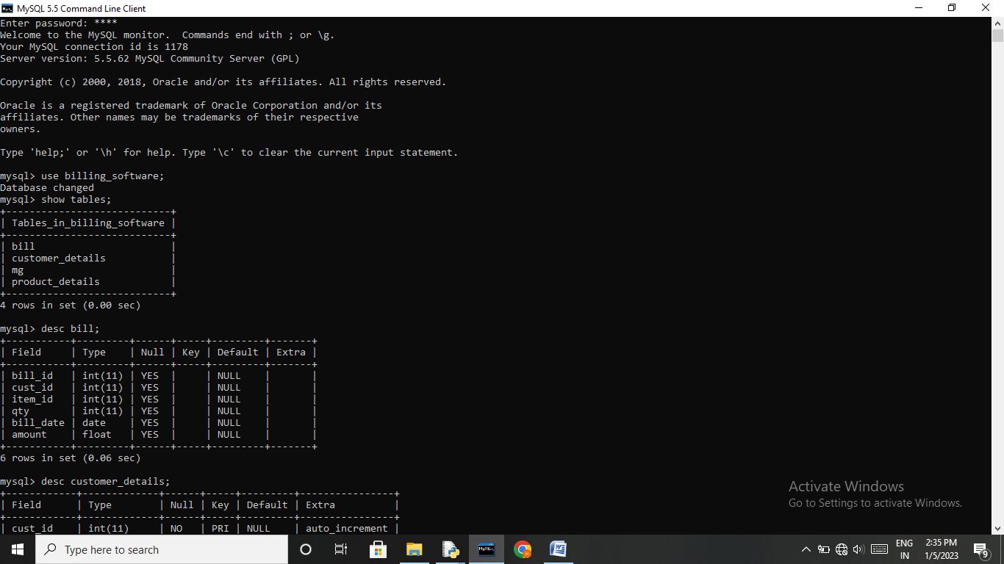

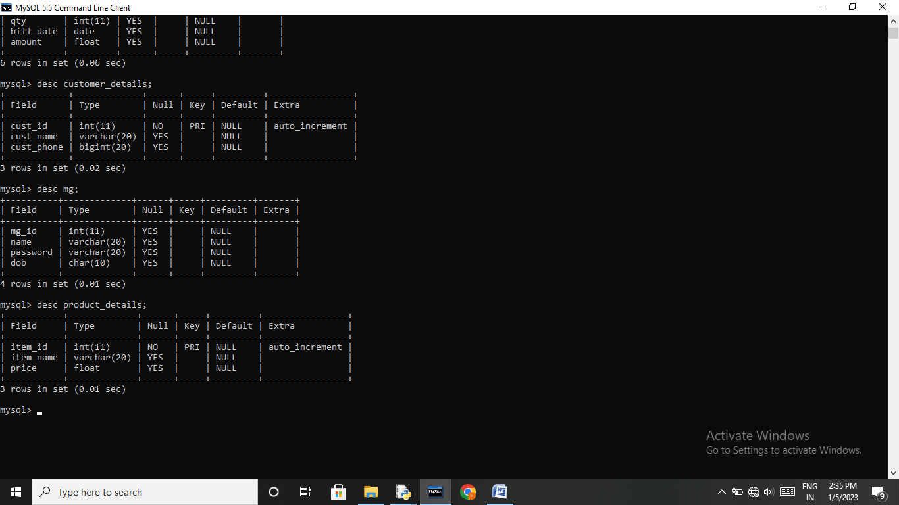

OUTPUT

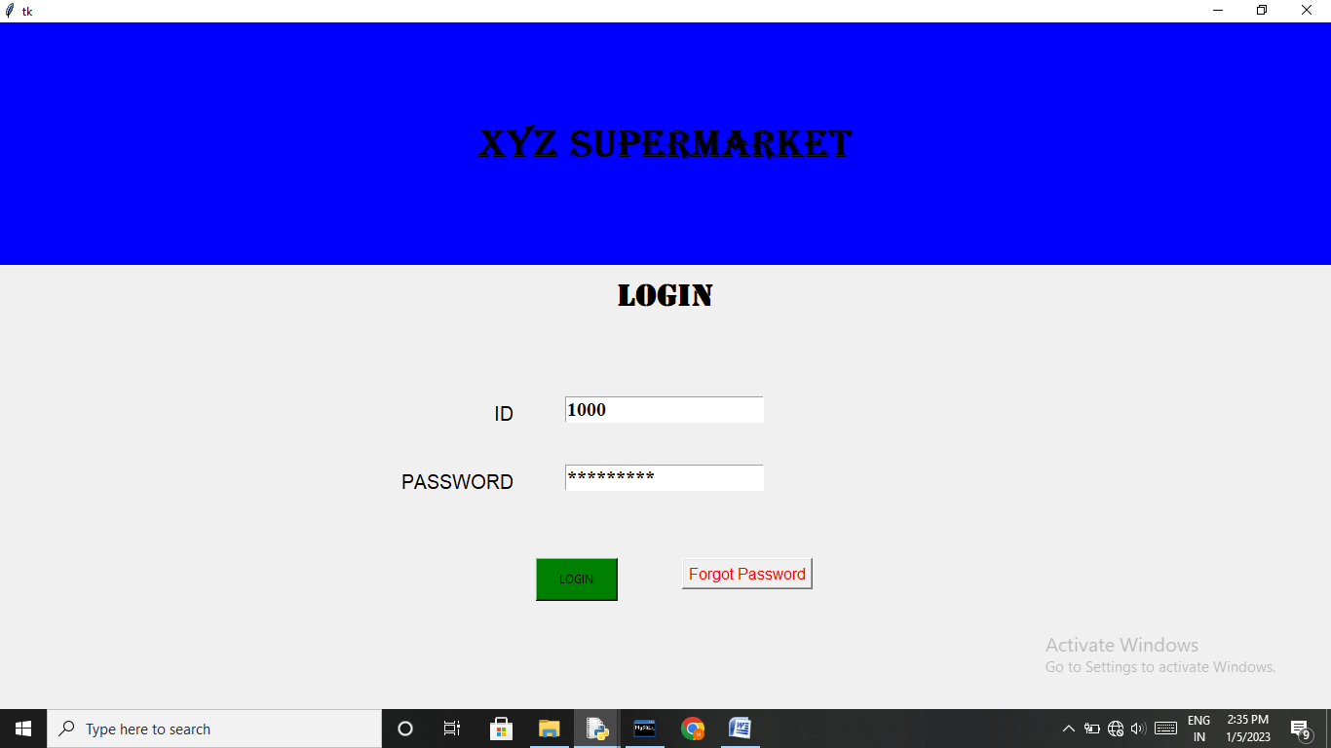

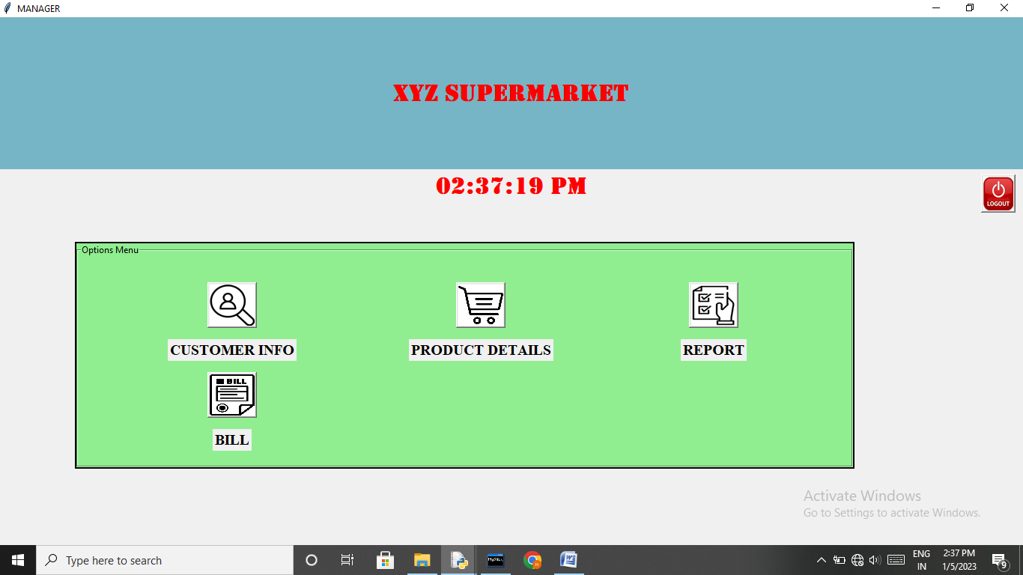

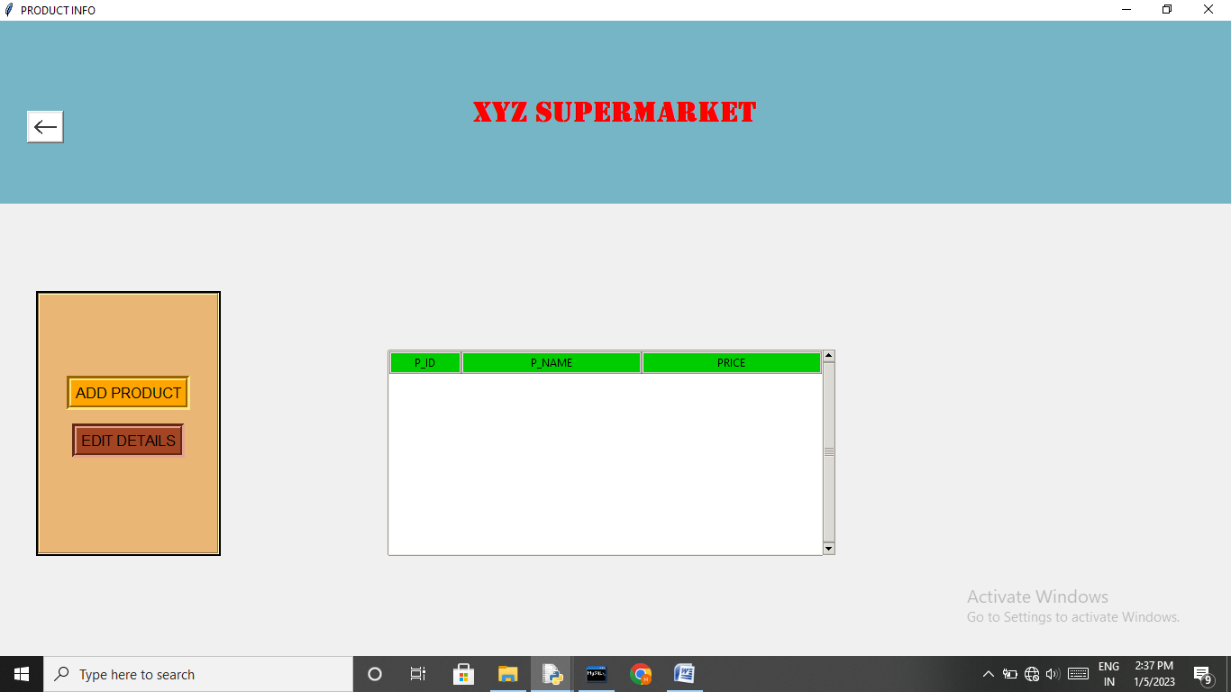

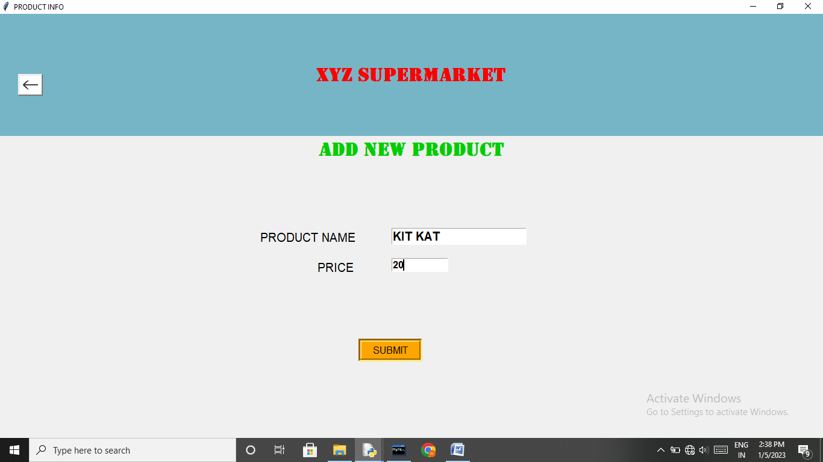
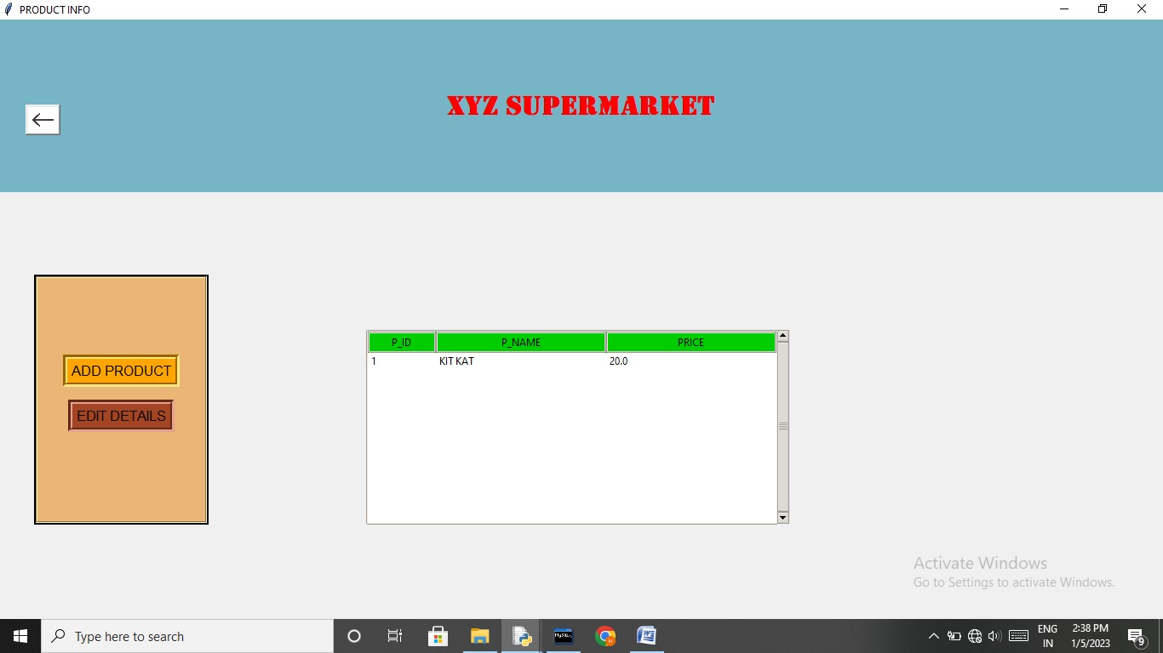

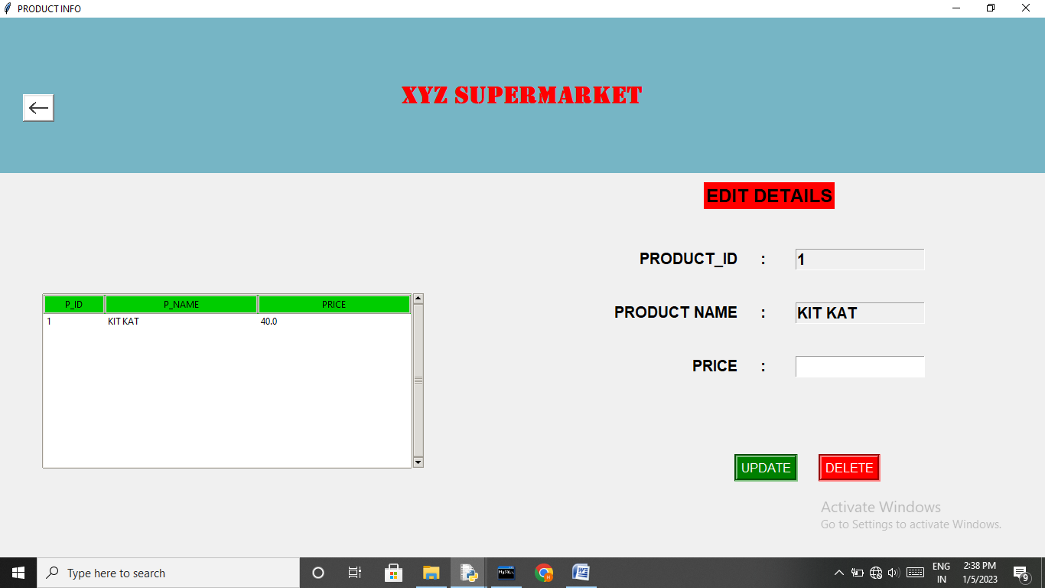
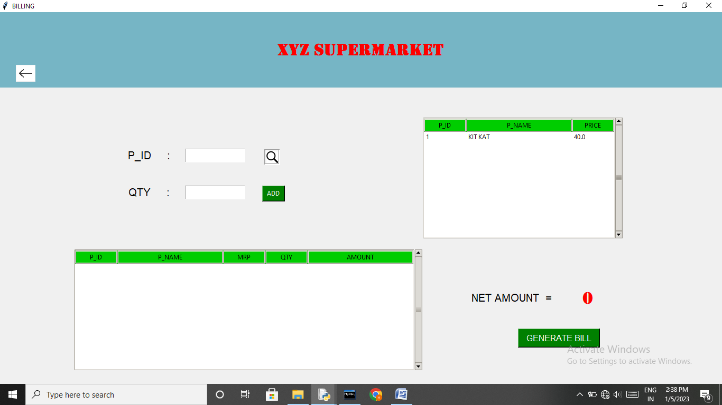

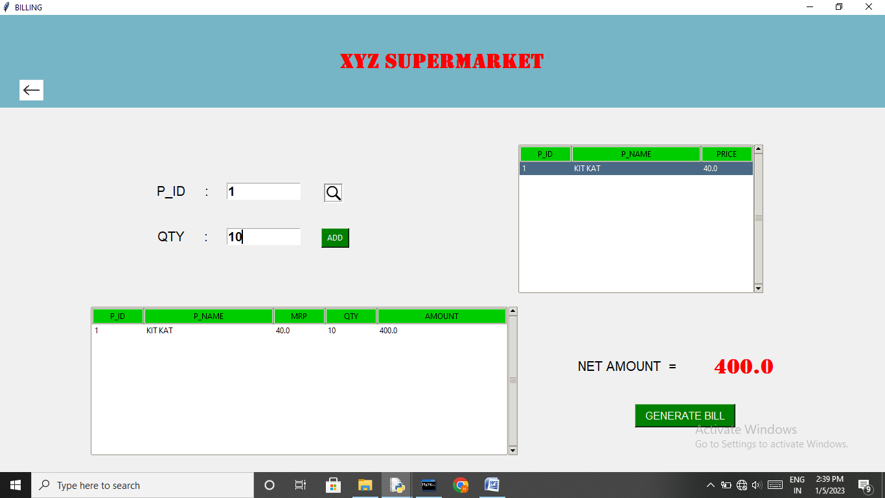
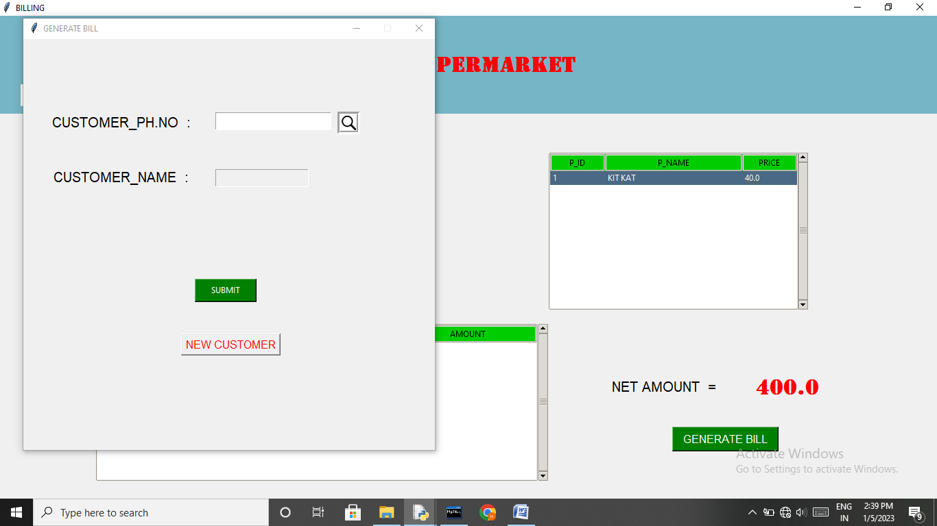

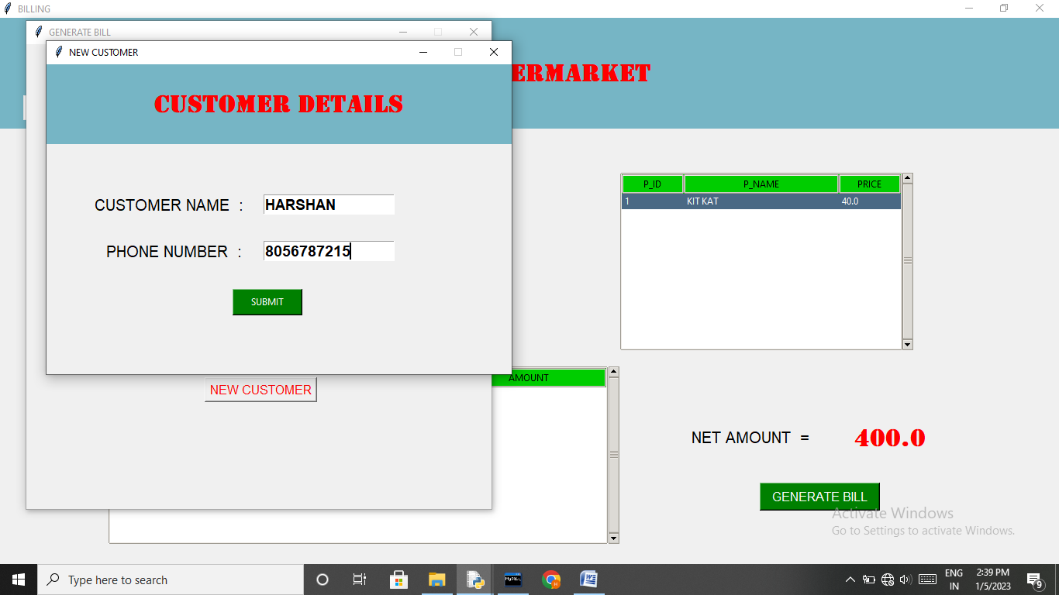
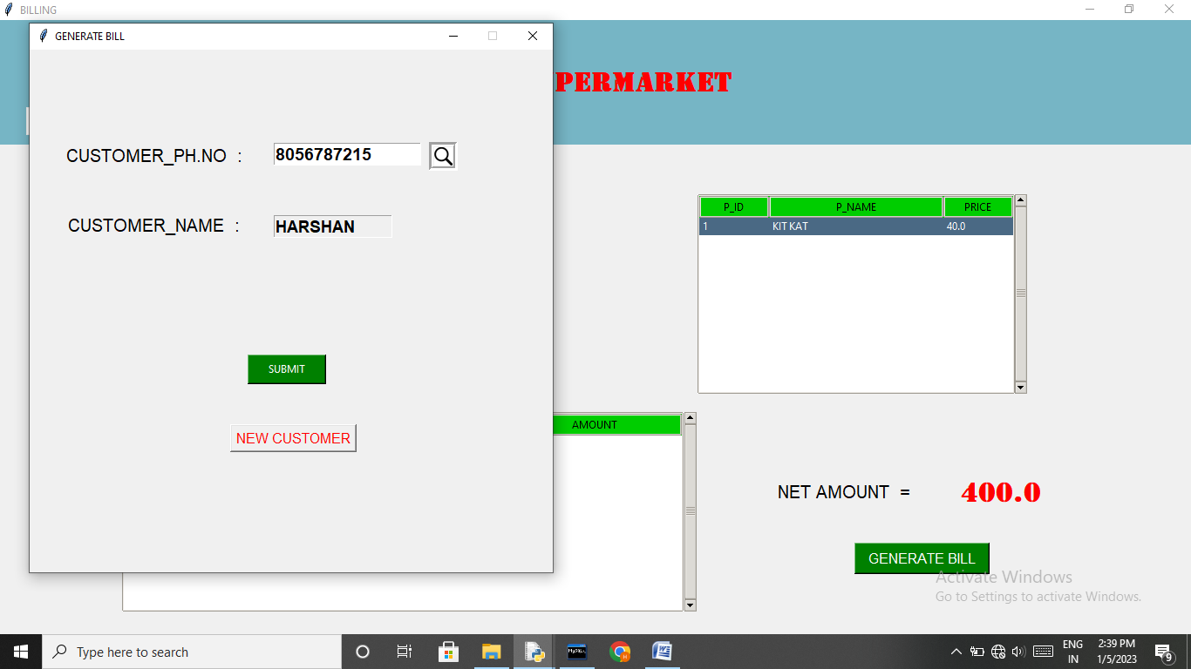

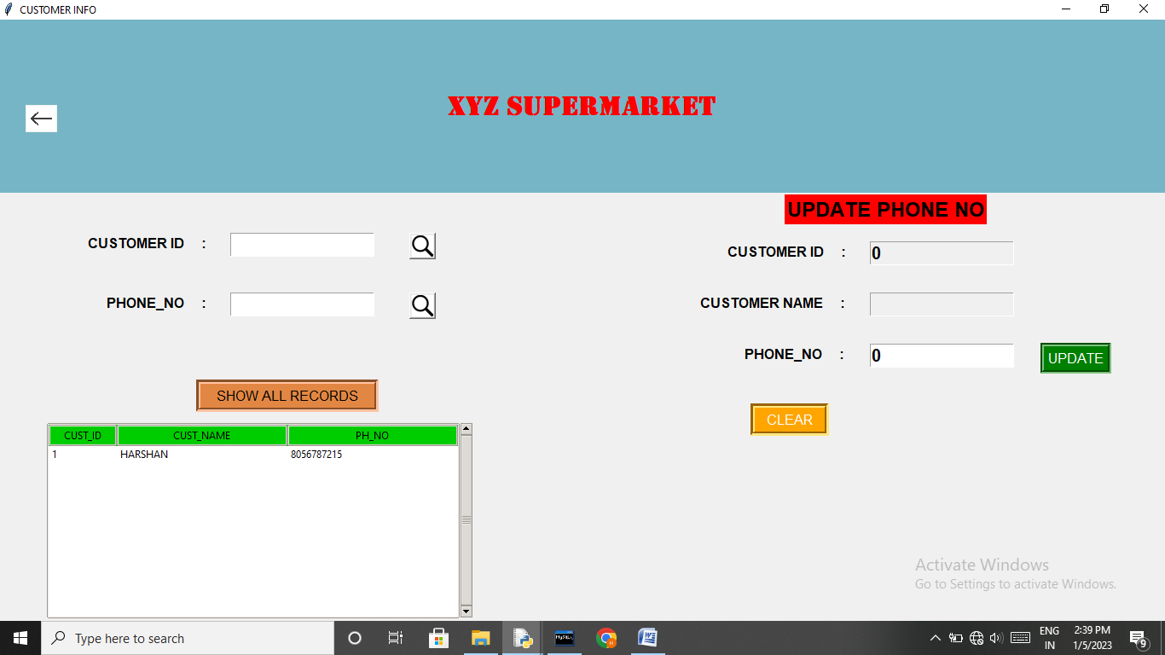

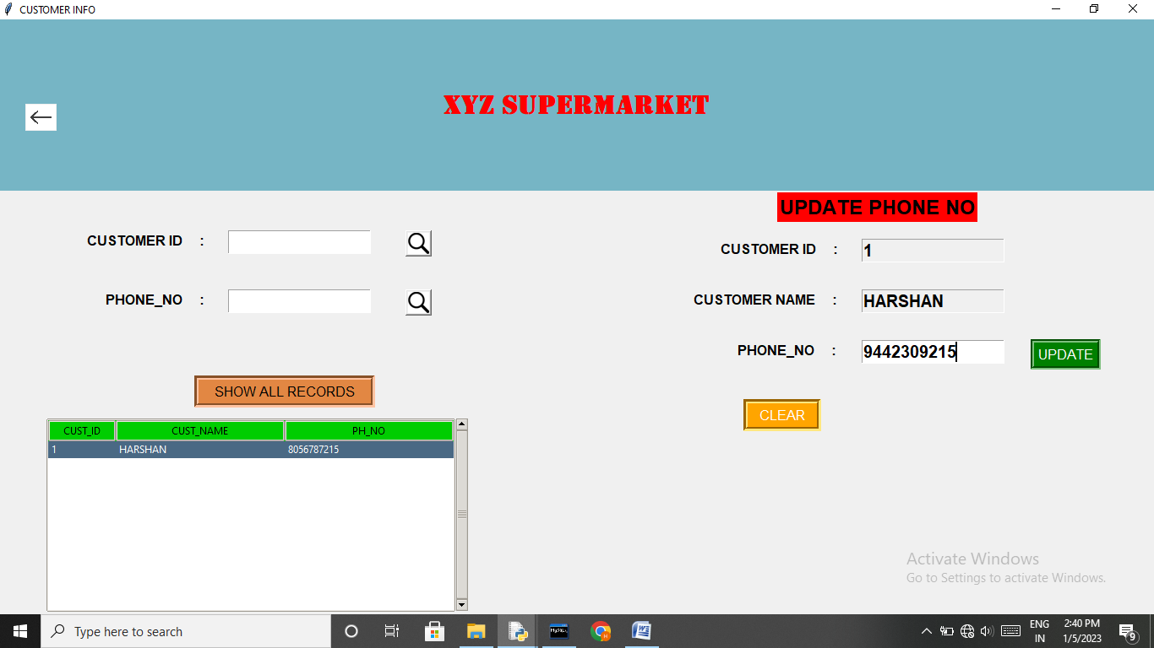

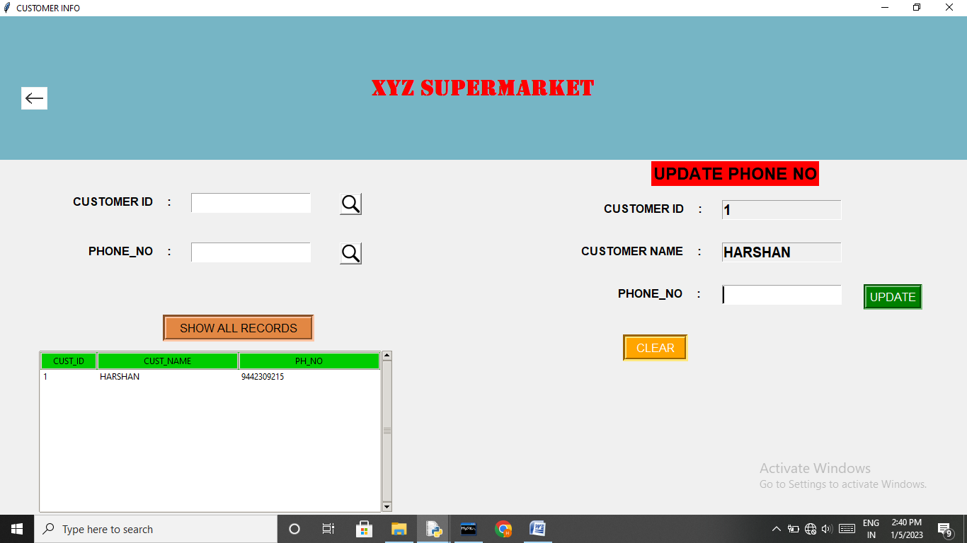

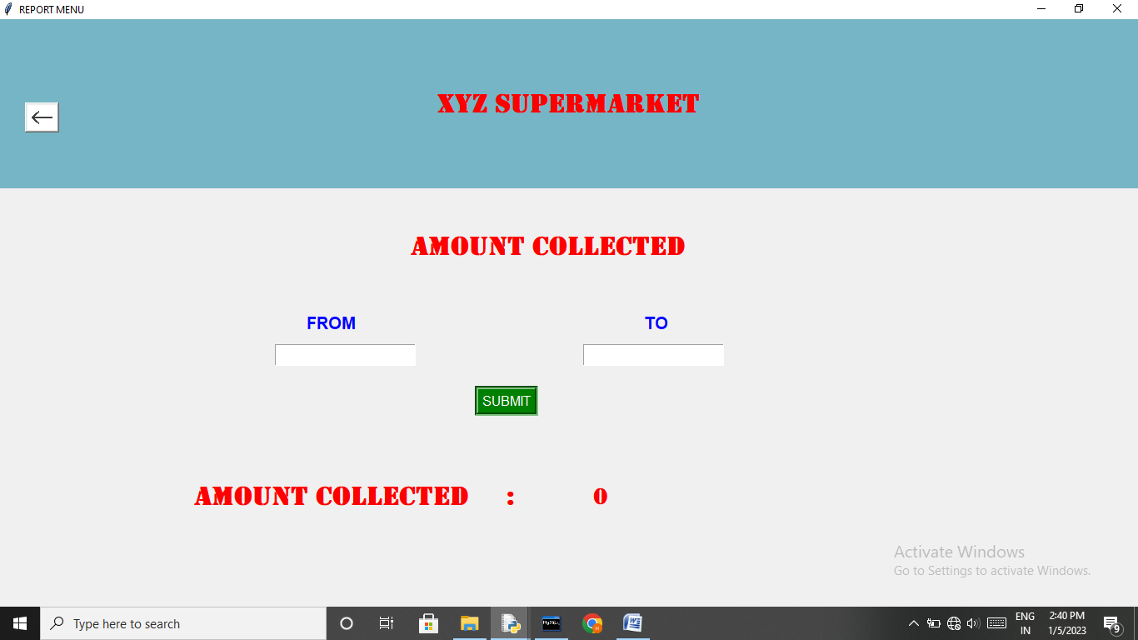

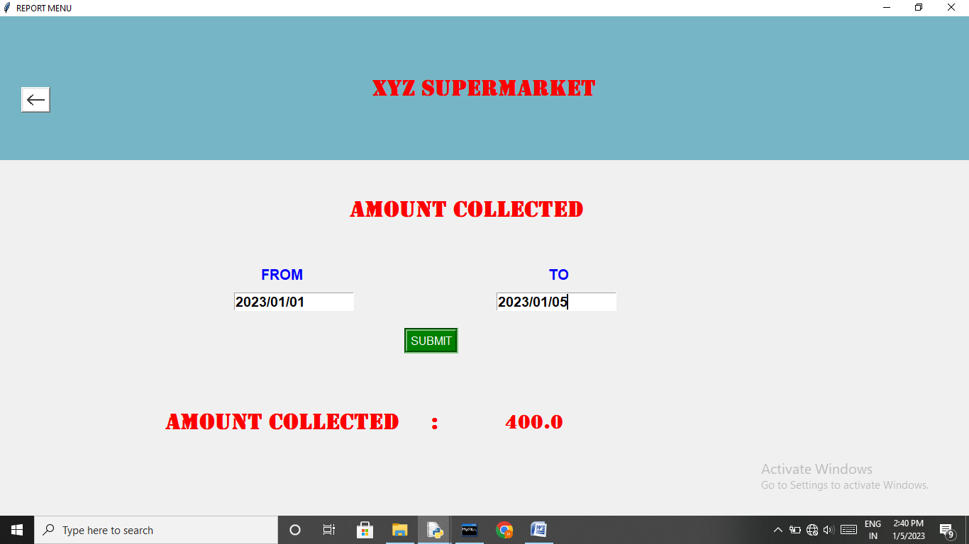

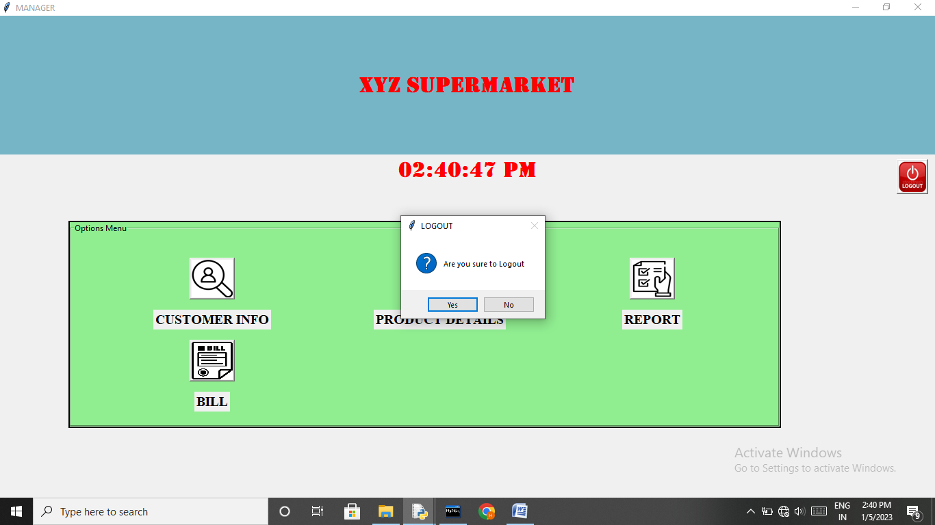

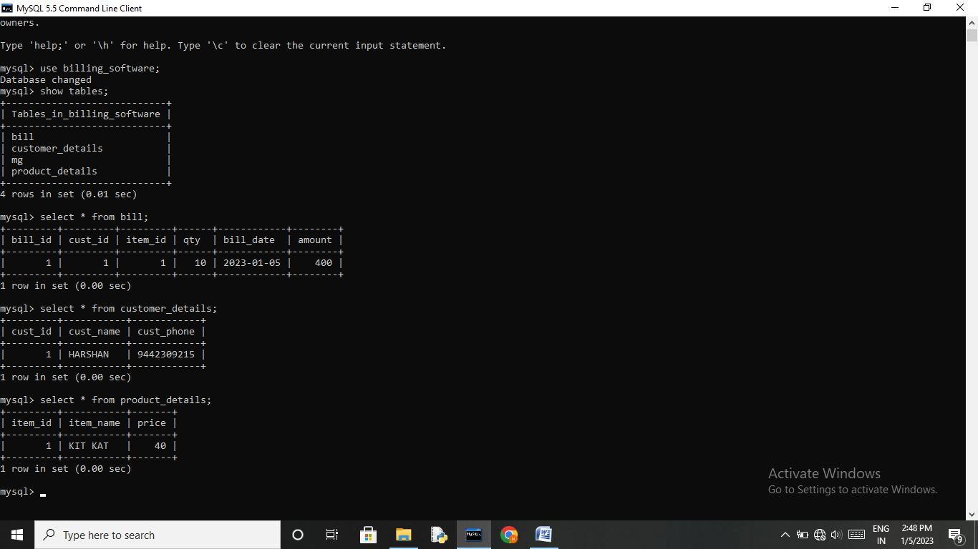

BIBLIOGRAPHY

- Computer science With Python - Class XI By : Sumita Arora
- Computer science With Python - Class XII By : Sumita Arora
- Computer science With Python - Class XI By : Preethi Arora
- Computer science With Python - Class XII By : Preethi Arora

WEBLIOGRAPHY

- Website: https://www.csiplearninghub.com
- Website: https://www.learnpython4cbse.com
- Website: https://www.python4csip.com
- Website: https://www.w3schools.com/
- Website: https://www.w3resource.com/

***

